<https://www.nationalgeographic.com/archaeology-and-history/magazine/2016/11-12/sparta-military-greek-civilization/> (helmet)

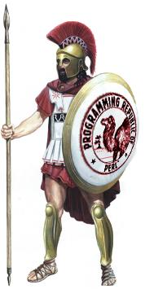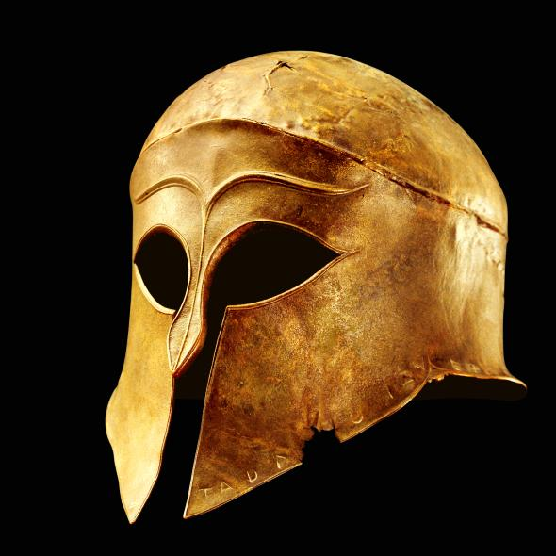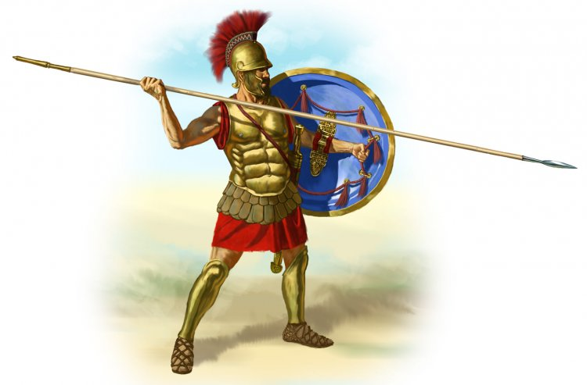<https://www.ancient.eu/hoplite/> (hoplite)

<https://qa.perl.org/phalanx/history.html> (hoplite left)

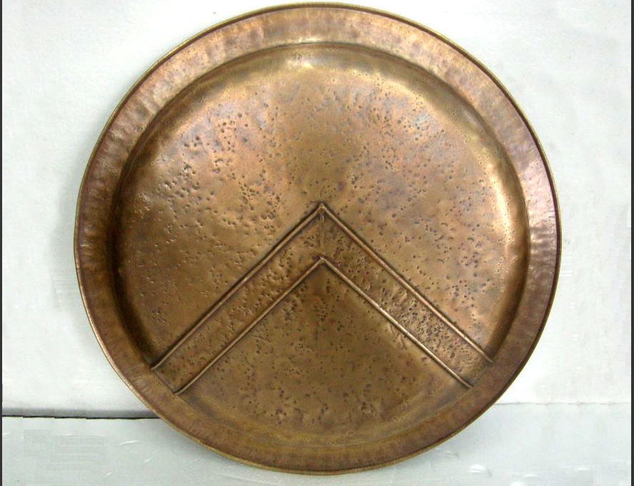

<http://www.hellenic-art.com/life-size-spartan-shield-of-king-leonidas-of-the-legendary-300-at-the-battle-of-thermopylae.html> (shield above right)